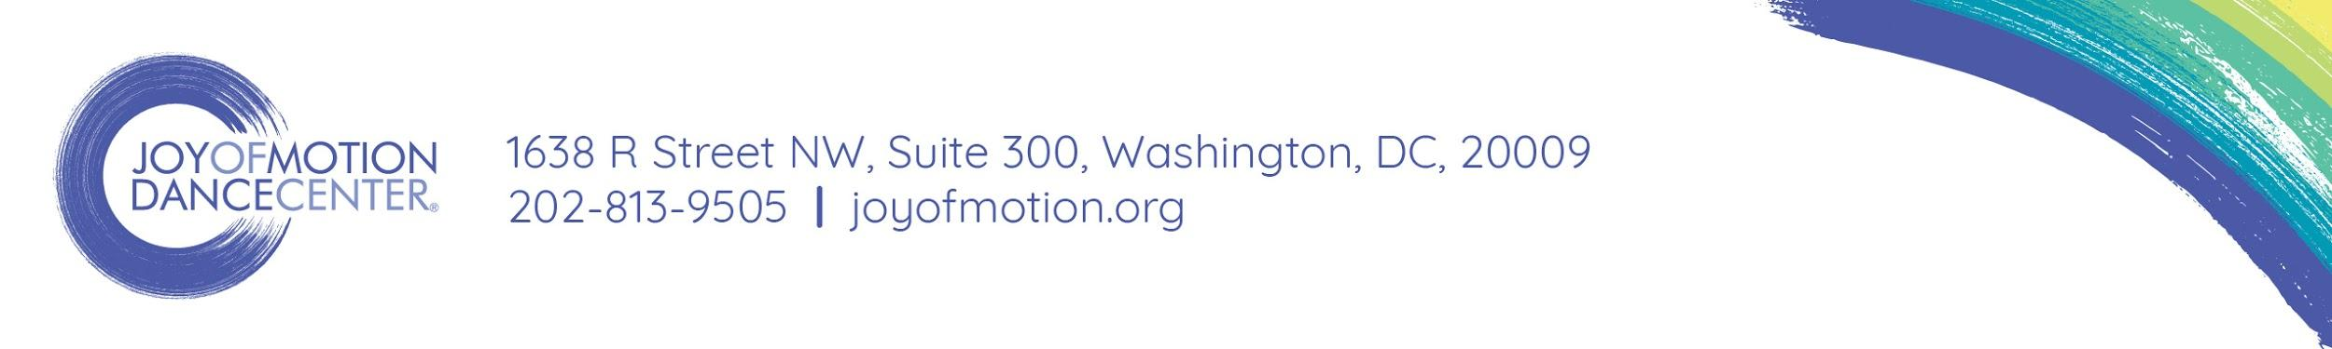
Joy of Motion Dance Festival
June 10, 2018

The annual Joy of Motion Dance Festival is a free and open-to-the-public celebration of arts education and performance in Fort Reno Park, DC, with 800 dancers, 100 performers & 4,000+ attendees.

Title Sponsorship - $50,000
- Name recognition as the event sponsor (“Joy of Motion Dance Festival presented by ___”) on all banners, signage, web, and print
- Reserved table with signage for a company representative at the Festival
- 12 months of full-page advertising in Joy of Motion concert and event programs
- Logo and link on the Joy of Motion website & name recognition in all studio locations
- Free class passes for adult Community Dance School classes (30 passes)

Stage Sponsorship - $10,000
- Naming opportunity for a performance stage (“The ____ Company Stage”)
- Reserved table with signage for a company representative at the Festival
- 12 months of ½-page advertising in Joy of Motion concert and event programs
- Logo and link on the Joy of Motion website & name recognition in all studio locations
- Free class passes for adult Community Dance School classes (15 passes)

Performance Sponsorship - $2,500 - $5,000
- 3-5 verbal recognitions prior to a live performance
- Reserved table with signage for a company representative at the Festival
- 3-5 months of ½-page advertising in Joy of Motion concert and event programs
- Logo and link on the Joy of Motion website & name recognition in all studio locations
- Free class passes for adult Community Dance School classes (10 passes)

Small Business Sponsorship - $500 - $1000
- Onstage thank-you at opening or conclusion of the Festival
- Logo and link on the Joy of Motion website & name recognition in all studio locations
- Free class passes for adult Community Dance School classes (5 passes)

ABOUT JOY OF MOTION:
- 3 studio locations in 2 Wards of DC and in Bethesda, MD
- 7,367 unique students and 91,623 visits to our studios in the last 12 months
- 3,300 page view daily on joyofmotion.org and 56,000+ students in our database
- 3,600 followers on Twitter and 10,200+ followers on Facebook
- Winner of “Best Dance Company” in Washington City Paper’s 2017 Best of DC

Joy of Motion Dance Center is a 501c3 nonprofit organization • www.joyofmotion.org

