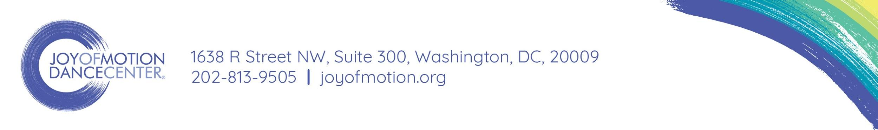
Center Stage Sponsorships
2017-18

Master Class Sponsorship - $250
- Solo name recognition as the event sponsor on our website and social media channels
- Direct link to your site in all marketing emails related to the class
- Prominent signage at the workshop and in the studio on the date of the class
- 1 free registration for the Master Class

Concert Sponsorship @ Jack Guidone Theatre (Capacity: 135) - $500
- Solo name recognition as the show sponsor on our website and social media channels
- Direct link to your site in all marketing and ticketing emails related to the show
- Name recognition on the cover of the concert program and in the curtain speech
- 2 free tickets to the concert or event

Concert Sponsorship @ Atlas Performing Arts Center (Capacity: 190-260) - $1,000
- All benefits detailed above, as well as:
- 4 free tickets to the concert or event and the option to display marketing materials

Concert Sponsorship @ Lisner Auditorium (Capacity: 1,400) - $3,000
- All benefits detailed above, as well as:
- 8 free tickets to the concert, option to display marketing materials, and presence in the lobby

2017-18 Season Sponsorship - $5,000
- Name recognition on all “Center Stage” Facebook events and pages on our website
- Direct link to your site in all marketing and ticketing emails related to our shows
- Recognition in all concert programs throughout the season
- 12 free tickets to be used for any concert or concerts throughout the season
- Option to display marketing materials at 3 shows of your choice
- Recognition at any concert that you attend and presence in the lobby

OUR REACH
- 3 studio locations in 2 Wards of DC and in Bethesda, MD
- 7,367 unique students and 91,623 visits to our studios in the last 12 months
- 3,300 page view daily on joyofmotion.org and 56,000+ students in our database
- 3,600 followers on Twitter and 10,200+ followers on Facebook
- Winner of “Best Dance Company” in Washington City Paper’s 2017 Best of DC

Joy of Motion Dance Center is a 501c3 nonprofit organization

